Dear Foysol:

From Jan to Feb, 2016, when we integrated the CCS801 module into our personal monitor products and had them tested, we encountered the situation that most of CCS801 became failed after some time (10-15 days). The operation mode of failed CCS801 was the pulse mode with the cycle time of 60s and operation voltage of 1.6V. The failed sensors had increased resistance and no response to VOC in room (where sensors showed alarmed level of VOC before failure). In our product (shown below), we didn’t use the CCMOS lib file to obtain the concentration of VOC.

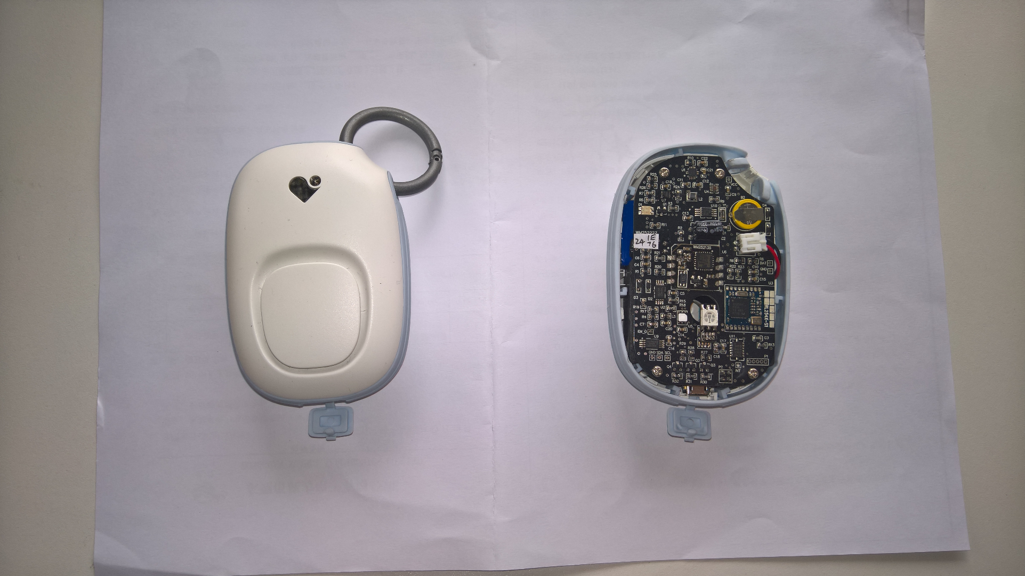

We reported this situation to Allen and Anthony on Feb, and were suggested to reduce the operation voltage to 1.4V. In addition, from March, we designed serial experiment trying to locate the reason of failure. Some of experiments have finished and some are ongoing, which are summarized below.

1 The mode that we operated the sensor, confirmed by Allen. Experiments were carried out only to capture the ADC value without converting to concentration by CCMOS lib or Weimu lib files.

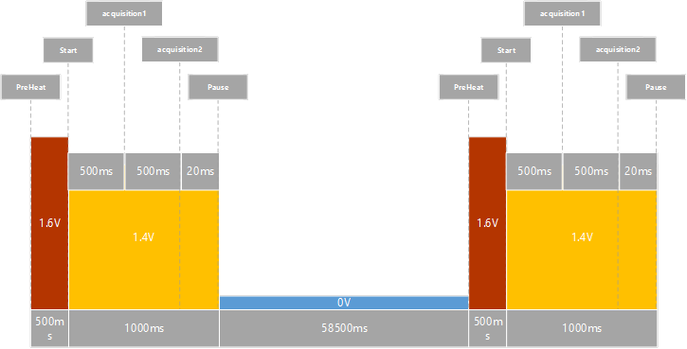

1.6V previously

2 Life time test by operating a batch of sensors (8 sensors) in a chamber with ultra-clean air generated by a zero-grade air generator. The operation is still in pulse mode and the voltage is 1.4V. After28 days, the resistance of sensors increased over 1.4M Ohm.

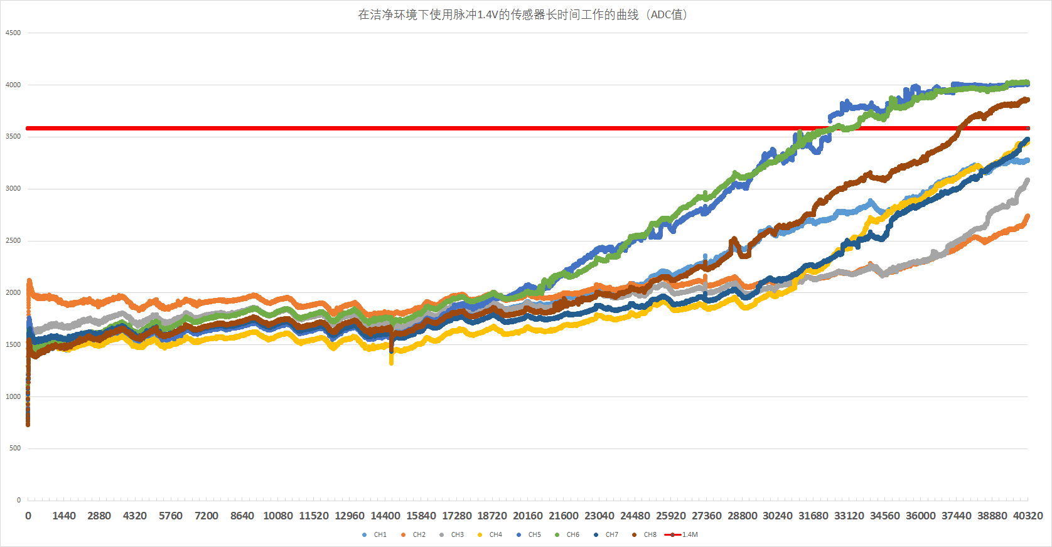

(This is the curve of ADC value, the red line is 1.4M when convert to resistance)

3 Life time test by operating a batch of sensors (8 sensors) in a chamber with high concentration alcohol (roughly 400k ppm by estimation from the generation method). The first 5 tests (1 tests per day) have a similar response. After that the resistance of 3-4 sensors went up to over 1.4M Ohm, and in the next 5 times the response became inconsistent with the first 5 times. The consistence of sensitivity of 8 sensors became worse than the initial 5 tests.

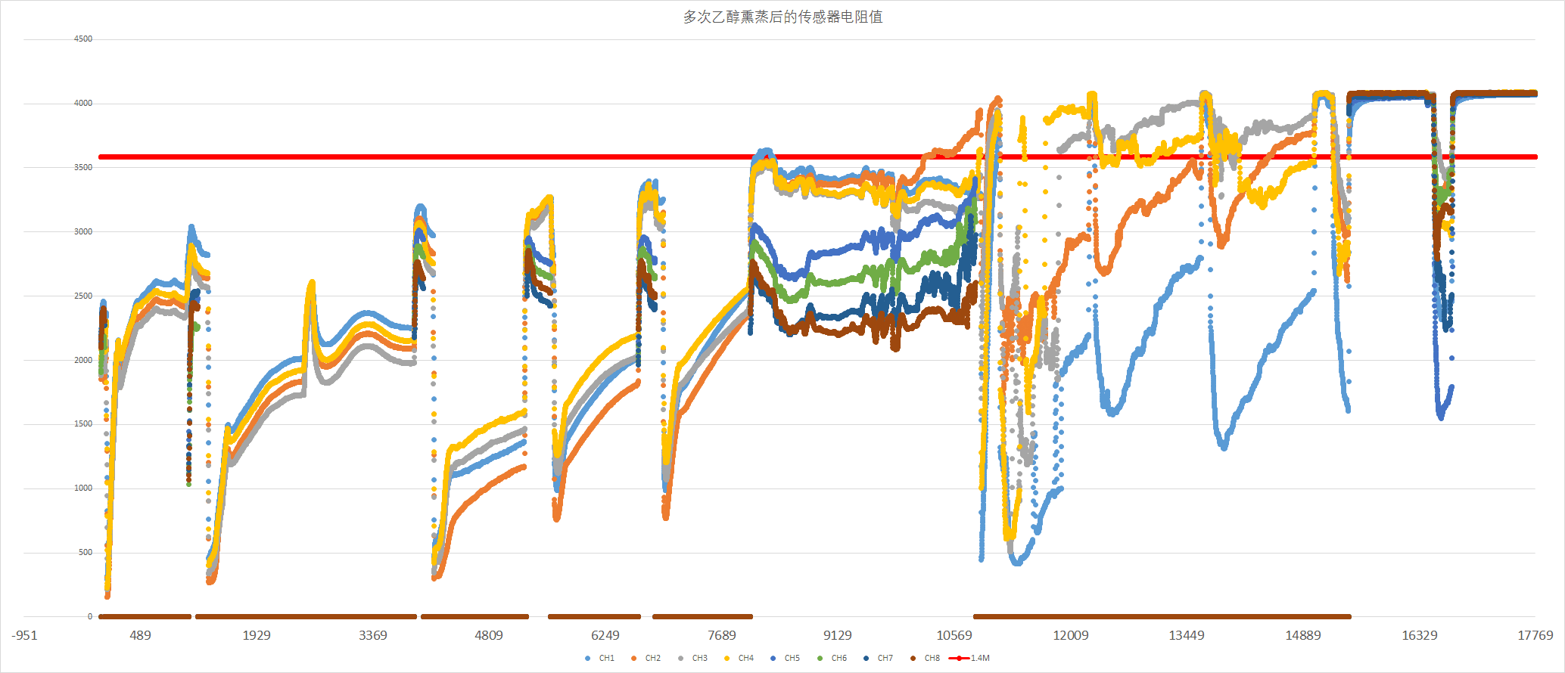

(This is the curve of ADC value, the red line is 1.4M when convert to resistance)

In this case if the sensor is poisoned, is there any way to regenerate? and any operation upper limit of VOC for CCS801?

4 Ongoing tests include:

1).      Compare continue and 60s pulse mode life time test in ultra-clean air (similar to point #2)

2).    Life time test of 4 sensors operated in 60s pulse mode in office environment, collecting data from CCMOS lib file.

3).   Integrate the CCS801 into our products again and life time test in office environment. The difference from previous failed tests on Jan and Feb is using 1.4V operation voltage this time.

To help us understand the performance of CCS801 better, we do need the following information:

1.      The data or report of testing formaldehyde by CCS801 using (60s) pulse mode.

2.      The data or report of long time scale baseline resistance (Rair) of CCS801 used in 60s pulse mode in clean air or room enviroment.

3.      The reliability testing report of CCS801 used in 60s pulse mode (supposed to be tested under 100ppm alcohol).

4.      The circuit schematic of the USB dongle.

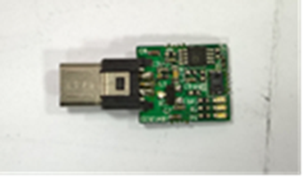

5 What is the standard for “failure” ? Have you done any other test in CCMOS to locate the reason of a failed sensor?

We have also communicated with Allen on above situation. We do appreciate if you could provide any suggestion or test method that we can do to fasten our test process.

If you need further detail, please send me an e-mail.

Thank you for your assistance.

Best,

Xiaozhi Wang